From Social Networks to Political Parties:

Indigenous Party-Building in Bolivia

## Online Appendix

Mariana Giusti-Rodríguez

Naval Postgraduate School

m.giustirodriguez@nps.edu

## A. Background: Coordinadora’s Resilient Network Environment

Much of the resilience of the *Coordinadora’s* social network environment, ironically, is owed to its messy and deeply fractured organizational beginnings. The coca growers’ movement, which the *Coordinadora* represents, traces its roots to the late 1970s, a period during which the Chapare region of Cochabamba experienced tremendous population growth.[1] Many of those who established themselves in the region became coca producers and, as the region grew, communities organized into unions to coordinate land titling processes and other local issues, and connected these unions through local federations.

In 1968, the first coca producers’ federation—FETCTC[2]—was founded. However, internal struggles, coupled with the population growth that ensued in the years after it was established, sent the organizational structure of coca growers into a downward spiral. In 1971, a sector split from FETCTC and created the FECCH[3] (Spedding 2005; Chávez León and Costas Monje 2005; Consultora Sistemática S.R.L. n.d.). In 1983, FECCH also divided and that fracture led to the foundation of the FCCT.[4] In 1986, FETCTC experienced another internal fracture, which led to the formation of the FUCU[5], and FUCU then underwent its own split in 1988, resulting in the creation of the FEYCH.[6] By the end of the 1980s, the *cocaleros* had established five different coca federations. Finally, in 1994, the FSAMBB[7] was created as a result of a new municipality law (Consultora Sistemática S.R.L. n.d.). Figure A1 charts these fractures.

**Figure A1**. **Social Network Splits in the Coca Growers’ Movement in Cochabamba**

Throughout the 1980s, these coca federations operated in isolation from each other. Crucially, this meant that each federation had independence when choosing their affiliations to other regional and national organizations. As a result, they inserted themselves in different network structures at the departmental and national levels. FETCTC—the largest and most powerful of the six federations—and FUCU became affiliated with the Cochabamba peasants’ federation, the FSUTCC, which in turn inserted them into the CSUTCB structure. The other four coca growers’ federations—FECCH, FCCT, FEYCH, and FSAMBB—for their part, affiliated with the FSCC[8], which embedded them in the national structure of the national confederation of colonizers, now referred to as *interculturales* (CSCB). Thus, two of the six federations became associated with the Cochabamba peasants’ federation and four attached themselves to the same department’s colonizers’ federation.

The *Coordinadora* emerged within this fractured context in 1991, as a strategy for unifying these federations (five of them at the time of its foundation) and facilitating their coordination in the fight against the increasingly militaristic coca eradication policies being implemented by the government, with the support of the US military. Importantly, however, despite their new affiliation to the *Coordinadora*, the federations’ connections to the various departmental and national networks did not change. The insertion of the *Coordinadora*—now the representative of the six federations—within this network landscape meant that the organization now had the unusual structural position of being formally embedded in both the FSUTCC and the FSCC at the departmental level as well as in the CSUTCB and CSCB—two of the most powerful indigenous peasant organizations—at the national one. Both of these national organizations also connected the *Coordinadora* to the COB.[9]

The structural landscape of the *cocalero* federations and the *Coordinadora* are represented in Figure A2. The figure on the left captures the network environment prior to the formation of the *Coordinadora* and the one on the right reflects how the formation of the *Coordinadora* altered this network landscape.

**Figure A2**. **Network Structure of Coca Growers’ Movement Pre- and Post-*Coordinadora***

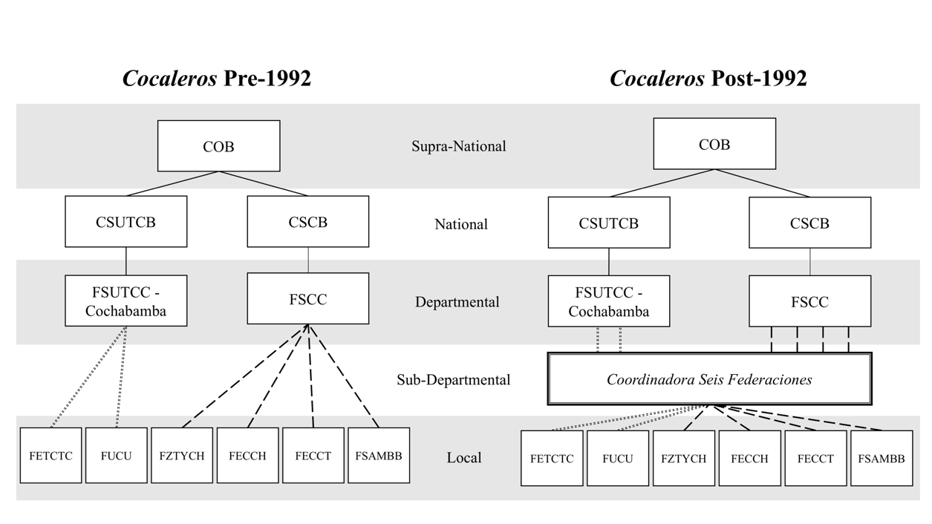

When MAS-IPSP was created from the *Coordinadora* structure, it had two independent internal paths to expansion into the departmental and national arenas from the sub-departmental level within which it operated. This would ultimately allow it to circumvent challenges from the competing political projects that emerged within FSUTCC and CSUTCB.

**B. Indigenous Organizational Networks in Bolivia Data Collection and Coding Strategy**

**Database**

10 Years of History, 2002-2011: 30 Days of News (*10 Años de Historia, 2002-2011: 30 Días de Noticias*)

**Citation**

Centro de Documentación e Información Bolivia, “10 Años de Historia, 2002-2011: 30 Días de Noticias,” (2012), CEDIB.

**Description**

Newspaper article database that includes more than 90,000 articles from the 2002-2011 period. Articles are a selection of the most significant news of the main national newspapers. Articles are organized by theme, year, and month and the full text of articles is included on and after 2003.

**Construction of database**

1. **Data collection Strategy**

The database was constructed based on the following guidelines:

1. ***Selection of articles:***
   1. Did the event ocur in **2003**? **YES** = continue
   2. Is the article categorized under one of the following themes and/or sub-themes (as established by CEDIB)? **YES** = continue

Socioeconomic relations (*Relaciones socioeconomicas*)

Labor conditions (*Situacion laboral*)

Miners and oil/gas workers (*Mineros, Petroleros*)

Agrarian sector (*Sector agrario*)

Factory workers (*Fabriles*)

Services (*Servicios*)

Coca: Drugs, Narcotrafficking, development, and the economy (*Coca: Drogas, narcotrafico y desarrollo e economía*)

Coca: Economy, narcotrafficking, and alternative development (*Coca: economía, narcotráfico, desarrollo alternativo*)

Coca: Fight against narcotrafficking (*Coca: Lucha contra el narcotráfico*)

Coca: Coca producers (*Coca: Productores de coca*)

Political Activity (Actividad politica)

Political Parties (*Partidos Políticos*)

Pressure Groups (*Grupos de Presión*)

Social Issues (*Sociales*)

Indigenous affairs (*Asuntos Indígenas*)

1. ***Selection into dataset:***
   1. Does the article title mention a social organization (e.g. Sin Tierra, *Coordinadora*, COB), social sectors (e.g. *cocaleros*, *empresarios*, *sectores*), an instance of collective action (e.g. blockades, protests, conflict, dialogue) an indigenous political party (e.g. MIP, MAS, ASP), or an indigenous party/organization leader (e.g. Evo Morales, Felipe Quispe (or Mallku), Alejo Véliz, Jaime Solares (COB)? **YES** = continue.
   2. Is the article about an action taking place (protest, meeting, or dialogue)? **YES** = continue. This excludes from the database opinion and analysis pieces, profiles, and other articles that do not capture event interactions within and/or between organizations.
   3. Is the event/activity discussed in the article content already included in the database? **NO** = add to dataset.
      1. If **YES**, does the article discuss new actors or developments in the event/activity? If **YES**=add to dataset.
2. ***Coding of relevant data gathered from newspaper articles:***
   1. **organizational actors:** Nodes/vertices. List of organizational actors mentioned in the article as participants in event/activity. Every social organization identified in article is interacted with every other organization mentioned in article as participating in event/activity (actor 1, actor 2).
   2. **type**: Node attribute. Classification of each actor as political party (‘party’), social organization (‘org’), or government (‘gov’) actor.
   3. **relationship**: Edge attribute. Does the event involve a positive interaction, negative interaction, or ongoing negotiations between actors?
   4. ***Positive interaction*:** Article indicates that organizations participated in protests, meetings, or negotiations and the outcome was an alliance and/or productive agreement.
   5. ***Negative interaction*:** Article discusses public statements, meeting, or negotiation outcomes that signal an organizational break within or between organizations. Examples include internal disagreements or splits, failed negotiations, and statements negating mobilization support to organizations requesting it.
   6. ***Negotiation*:** Article discusses ongoing negotiations without clear outcome.
   7. ***Single actor*:** Article discusses single organization. No inter- or intra-organizational interaction.

**NETWORK DATASET**

The network dataset employed for this article includes only organizational interactions between actors that are coded as social organizations (*type*) and interactions (*relationships*) that are coded as positive. All other actors and organizational interactions are excluded from the analyses.

The dataset is in the form of an igraph object. It includes the following variables/properties:

1. **name**: name of social organization.
2. **label:** name of social organization (same as **name**).
3. **type**: node attribute capturing type of organization.
   1. **levels**: gov, org, party [only org included in this dataset]
4. **degree:** node attribute capturing degree centrality measure.
5. **key_nodes:** node attribute capturing significance of nodes for analysis. Significant nodes are categorized as ‘key’; the remaining nodes are categorized as ‘other’. Key nodes include *Coordinadora*, FSUTCC, FDUTC-LP “TK”, CSUTCB, and COB.
6. **relationship:** edge attribute that captures whether the event was a (1) positive interaction, (2) negative interaction, (3) ongoing negotiation without clear outcome, (4) single actor/no interaction. Graph is a subset that includes only instances of positive interactions given focus of analysis.

**References**

Chávez León, Marxa, and Patricia Costas Monje. 2005. *Sociología de Los Movimientos Sociales En Bolivia: Estructuras de Movilización, Repertorios Culturales y Acción Política*. Edited by Álvaro García Linera. La Paz: DIAKONIA Acción Ecuménica Sueca: OXFAM.

Consultora Sistemática S.R.L. n.d. “Diagnóstico a Las Organizaciones Sociales de Productores de Hoja de Coca de Los Departamentos de Cochabamba y La Paz.” La Paz, Bolivia: Control Social. Accessed June 29, 2018.

Flores, Gonzálo, and Jose Blanes. 1984. *¿Donde vá El Chapare?* Cochabamba, Bolivia: CERES.

Spedding, Alison. 2005. *Kawsachun Coca: Economía Campesina Cocalera En Los Yungas y El Chapare*. La Paz: PIEB.

1. Migration to the Chapare resulted partly from the spike in the price of coca leaves in 1980—which attracted immigrants from Potosí, La Paz, and Oruro—and partly from the mass migration of former miners triggered by the privatization of the mining industry in 1985 (Spedding 2005; Flores, Gonzálo and Blanes 1984; Chávez León and Costas Monje 2005).
2. Special Federation of Peasant Workers of the Cochabamba Tropic
3. Colonizers' Federation of Chimoré
4. Carrasco Tropical Colonizers' Federation
5. Unitary Federation of United Centrals
6. Yungas del Chapare's Special Federation
7. Mamoré-Bulo Bulo Agropecuarian Syndicate Federation
8. Colonizers' Syndicate Federation of Cochabamba
9. In addition to this structure, each of the federations in the Chapare also had a parallel coca growers women’s federation. These six women federations were themselves affiliated, at the departmental level, with the Cochabamba’ women’s peasant federation (FDMCOC – B.S.) and at the national level with the CNMCIOB – B.S. and the CSUTCB (Consultora Sistemática S.R.L. n.d.; Spedding 2005; Chávez León and Costas Monje 2005).